|  |  |
| --- | --- |
|  | **AMERICAN INTERNATIONAL UNIVERSITY-BANGLADESH (AIUB)**  Faculty of Engineering  Department of EEE and CoE  Undergraduate Program |







|  |  |
| --- | --- |
| **Course:** Introduction To Electric Circuit | **Exp No: 02** Fall :2021 |

|  |
| --- |
| **Title:** Verification of Kirchhoff’s Voltage Law (KVL) and Kirchhoff’s Current Law (KCL) |

Submitted by

|  |  |  |  |
| --- | --- | --- | --- |
| **Name** | **ID** | **Signature** | **Contact Details** |
| Ankon Sarker linkon | 19-40895-2 | Ankon | 01767553784 |

Group Members:

|  |  |  |  |
| --- | --- | --- | --- |
| **SL** | **Name** | **ID** | **Signature** |
| 01 | Ankon Sarker linkon | 19-40895-2 |  |
| 02 | Himel Datta | 19-41576-3 |  |

**Due Date:27.9.21 Submission Date:27.9.21**



**Submitted To**

**FACULTY NAME**

Faculty of Engineering

Department of EEE  
American International University-Bangladesh

**Abstract**: There are two sections in this experiment. In the first circuit Kirchhoff s Voltage Law (KVL) will be verified and in the second Kirchhoff’s Current Law (KCL) will be verified.

**Introduction**: Kirchhoff's circuit laws are two approximate equalities that deal with the current and potential difference (commonly known as voltage) in electrical circuits. They were first described in 1845 by Gustav Kirchhoff. This generalized the work of Georg Ohm and preceded the work of Maxwell. Widely used in electrical engineering, they are also called Kirchhoff's rules or simply Kirchhoff's laws. The purpose of this experiment is:

• To develop an understanding of Kirchoff’s Voltage Law (KVL) and Kirchoff’s Current Law (KCL) practically.

• And finally measured values are going to be verified with calculated values.

**Theory and Methodology**:

**Kirchoff’s Voltage Law (KVL):**

Kirchoff’s Voltage Law (KVL) in a DC circuit states that,"the algebraic sum of the Voltage drop around any closed path is equal to the algebraic sum of the Voltage rises”. In other words, "the algebraic sum of the Voltage rises and drops around any closed path is equal to zero”. A plus (+) sign is assigned for the potential rises (- to +) and minus sign (-) is assigned to a potential drop (+ to -). In symbolic form, Kirchoff’s Voltage Law (KVL) can be expressed as

∑cV=0, Where C is used for closed loop and V is used for the potential rises and drops.

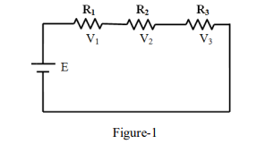

**Kirchoff’s Current Law (KCL):**

Kirchoff’s Current Law (KCL) in a DC circuit states that," the algebraic sum of the currents entering and leaving an area, system or junction is zero”. In other word, "the sum of the currents entering an area, system or junction must be equal the sum of the currents leaving the area, system or junction”. In equation form,

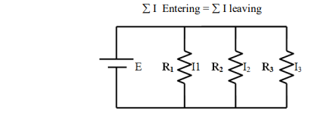

Figure-2

: **Apparatus :**

|  |  |  |  |
| --- | --- | --- | --- |
| SI. No | Name | Rating | Quantity |
| **1** | Trainer Board |  | **1** |
| **2** | Resistors |  | **3** |
| **3** | Connecting wire |  | **10** |
| **4** | Multimeter |  | **4** |
| **5** | DC source | **9V** | **1** |

**Circuit Diagram:**

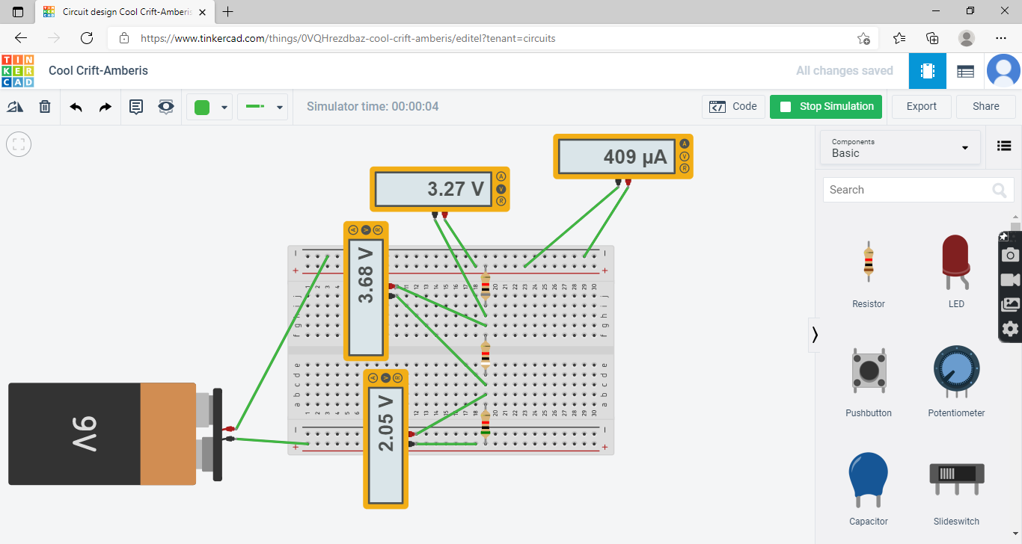

**Figure1: Circuit of verification of KVL**

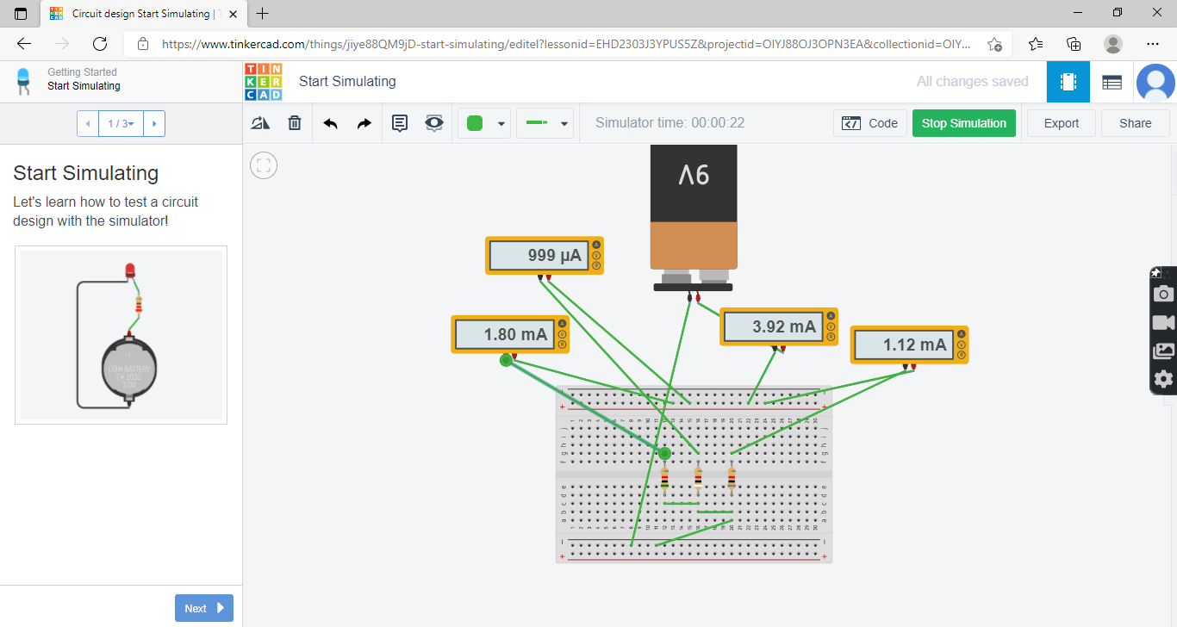

**Figure2: Circuit of verification**

**Table -1**

|  |  |  |  |  |  |  |  |  |  |  |  |  |  |  |
| --- | --- | --- | --- | --- | --- | --- | --- | --- | --- | --- | --- | --- | --- | --- |
| No. of obs. | R1  KΩ | R2  KΩ | R3  KΩ | V | | V1 | | V2 | | V3 | | V=V1+V2+V3 | | %Error = %(mvcv)/cv |
| C  A | M  A | C  V | M  V | C  V | M  V | C  V | M  V | C  V | M  V |
| 1 | 8 | 9 | 5 | 0.409 | 0.409 | 3.272 | 3.27 | 3.681 | 3.68 | 2.045 | 2.05 | 8.998 | 9 | 0.022% |
| 2 | 5 | 7 | 6 | 9 | 9 | 2.5 | 2.5 | 3.5 | 3.5 | 3 | 3 | 9 | 9 | 0% |

**Table-2**

|  |  |  |  |  |  |  |  |  |  |  |  |  |  |  |
| --- | --- | --- | --- | --- | --- | --- | --- | --- | --- | --- | --- | --- | --- | --- |
| No. of obs. | R1  KΩ | R2  KΩ | R3  KΩ | I | | I1 | | I2 | | I3 | | I=I1+I2+I3 | | %Error = %(mvcv)/cv |
| C  A | M  A | C  A | M  A | C  A | M  A | C  A | M  A | C  A | M  A |
| 1 | 8 | 9 | 5 | 3.927 | 3.92 | 1.125 | 1.12 | 1 | 1 | 1.8 | 1.8 | 3.925 | 3.92 | -0.128% |
| 2 | 5 | 7 | 6 | 4.5871 | 4.58 | 1.8 | 1.8 | 1.28571 | 1.28 | 1.5 | 1.5 | 4.58571 | 4.58 | -0.1245% |

**Calculations:**

**For KVL:**

R1 = 8KΩ

R2 = 9 KΩ

R3 = 5 KΩ

R = R1+R2+R3 = (8+9+5) KΩ

= 22 KΩ

I = E/R=(9/22)=0.409A

Now,

V1 = I×R1 = 0.409*8= 3.272 V

V2 = I×R2 = 0.409*9=3.681 V

V3 = I×R3 = 0.409*5=2.045 V

So,

V1+V2+V3 = (3.272+3.681+2.045)= 8.998V

**For KCL:**

R1 = 8KΩ

R2 = 9 KΩ

R3 = 5 KΩ



=2.292 Ω

We know,

I = E/R=(9/2.292)=3.927A

I1 = E / R1=1.125A

I2= E/R2 =1A

I3= E/R3=1.8A

I= I1 + I2 + I3==3.925A

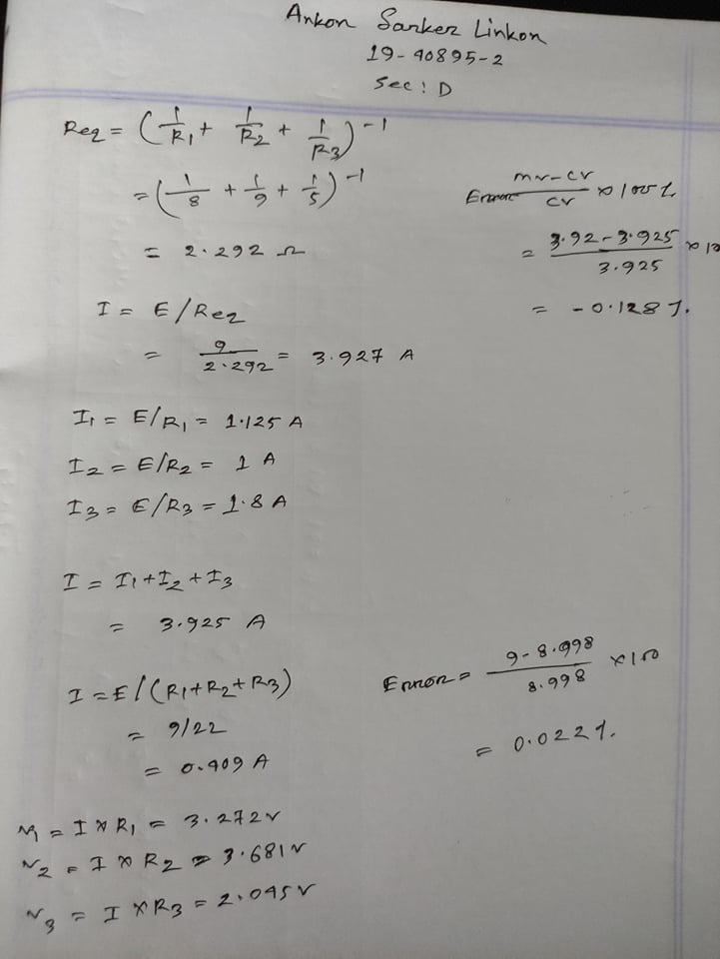

**Discussion:**

1. The data/findings were interpreted and determine to the extent to which the experiment was successful in complying.

2. The goal was initially set.

3. The ways of the study could have been improved, investigated and described.

**Conclusion:**

In this experiment KVL and KCL was observed and verified.